

Changing Lives Through learning

**Student Name-Rajwinder Kaur**

**REPORT STRAT**

# Client Details

Rajwinder is my client. He is my friend. He went to know about New Zealand. I proposed to a new website to expand his Konwlege. The name is “NEW ZEALAND”.

|  |  |
| --- | --- |
| Website Name | NEW ZEALAND |
| Address | 2/136 RANGITOTO ROAD,PAPATOETOE |
| Phone Number | 0225477062 |
| Email Address | [rajwinderbhullar126@gmail.com](mailto:rajwinderbhullar126@gmail.com) |
| website creater | Rajwinder kaur |

# Project scope

## Purpose

The main purpose of the website is to attract customers more and more to come the NEW ZEALAND. This website is very simple and attractive. People can follow it easily. This website can be used with all browsers like opera browser, safari, Google chrome, internet explorer, Firefox.

## Goals

* Attracts customers

This website has lot of knowledge and picture of NEW ZEALAND with good color schema and visible contant. It looks very beautiful and help to improve the interest of costumer.

* Knowledge of Booking

This assignment gives the knowledge about the booking of events, attractions and hotels of NEW ZEALAND.

## Features

* Online booking

People can book rooms ,book tickets of the events and attractions online by the adding their details on the booking page.

Awareness of the customer

This website can aware the customer by creating the profile on the website.

* Information about location

People can search the location of hotels, attractions and events easily while your bookings of the website.

* Customers details

The website also gives the information to the customer like their phone number, Address, e-mail id.

## Target audience

* Men age group 18-40
* Women age group 18-40
* Children age group 8-16

# Visual Planning

1. Home page

This given website new zealand.co.nz is the website of “NEW ZEALAND”. This website has no negative space.it also gives the information of the NEW ZEALAND like location OF ATTRACTIONS, HOTELS, customer details, EVENTS OF NEW ZEALAND and more . The colour schema of this website, is enhancing the beauty of the website.

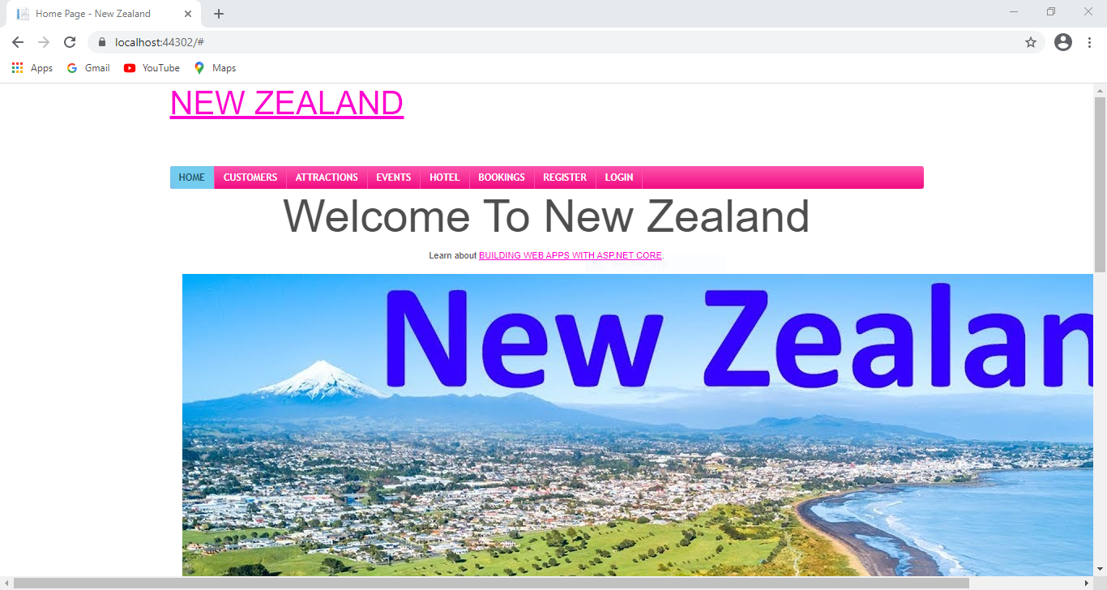

1. Costumer page

This is the website costumer page. This website provides the information about NEW ZEALAND page as well as the delete, detail, edit and create button. This website page is giving the information about the history of new Zealand with photos and taglines. some design principles also like unity, the font used in the website is increases the attraction of the customers as emphasis view point.

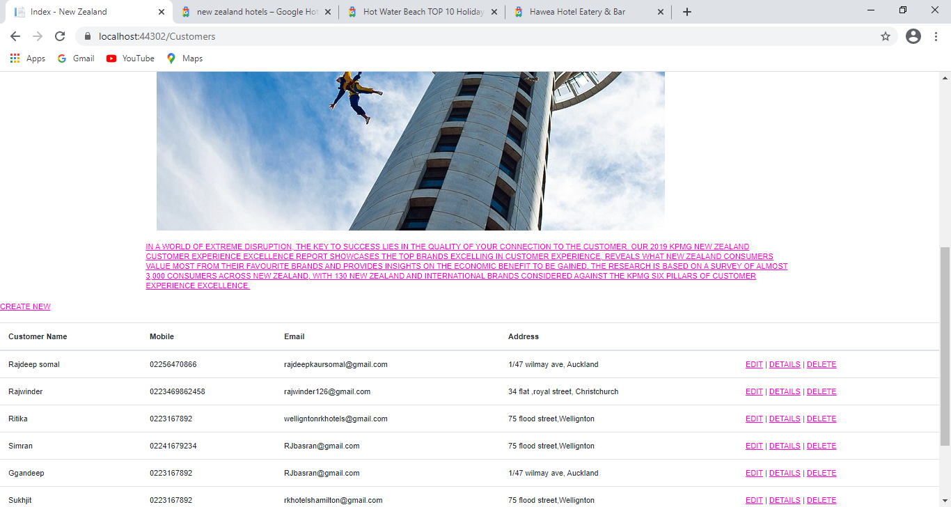

1. Attraction page

This is attraction page. This page includes the information of the attractions details and booking details. The website describes balance as well as alignment.

(Balance Symmetrical designs are always pleasing, . Asymmetrical designs are bolder and can bring real visual interest and movement (more on that later!) to your composition) there are many attractions are given in this page .

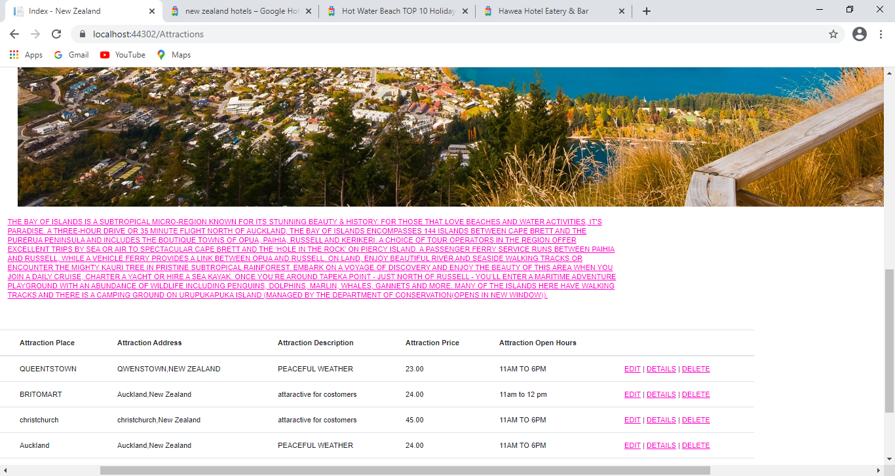

1. event page

The forth page is events page. This page includes the information of the events details. The website describes contrast from the design principals by its simple design.there are many events of new Zealand are mentioned in this page with details.it is very interesting part.

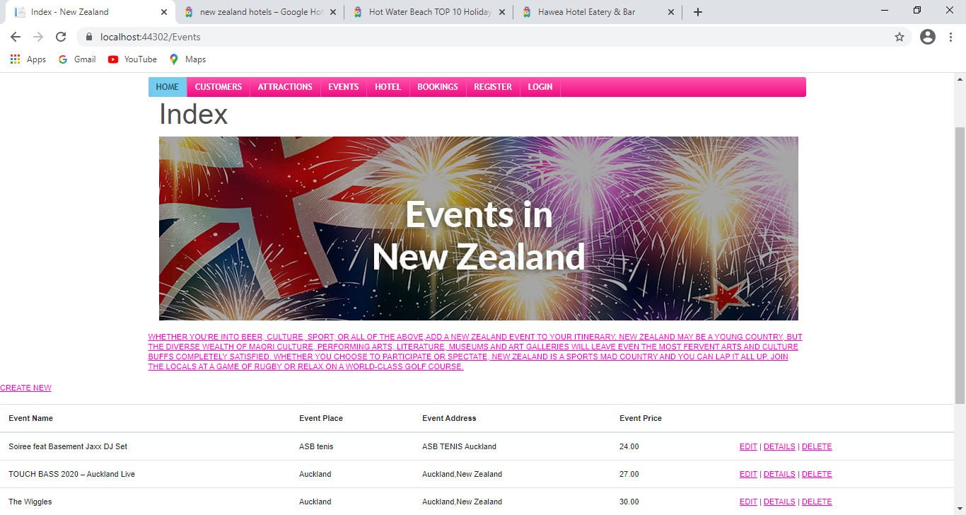

1. Hotels page

The NEXT PAGE is hotels. This page includes the information of the hotels details which shows the available services in the hotel. The website describes contrast from the design principals by its simple design.

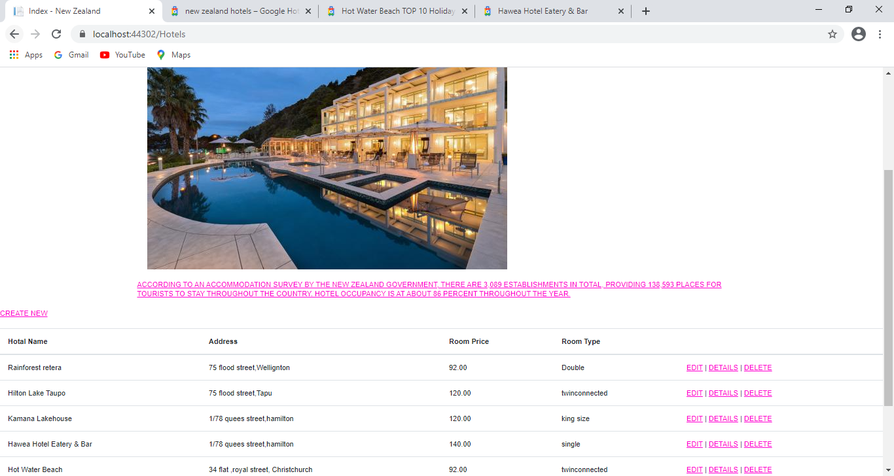

1. Bookings page

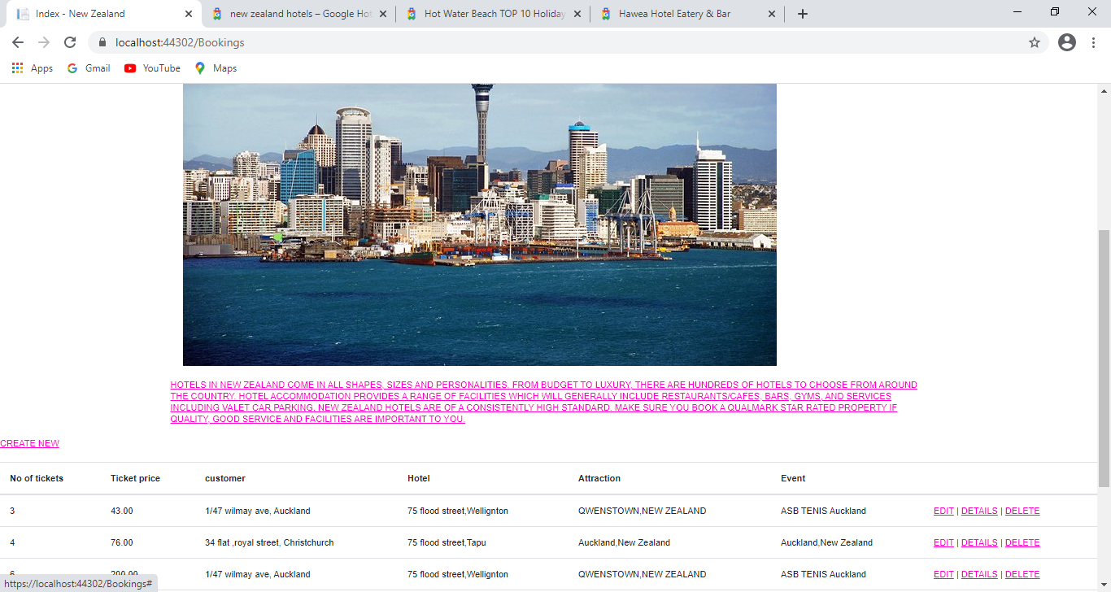

1. Footer area

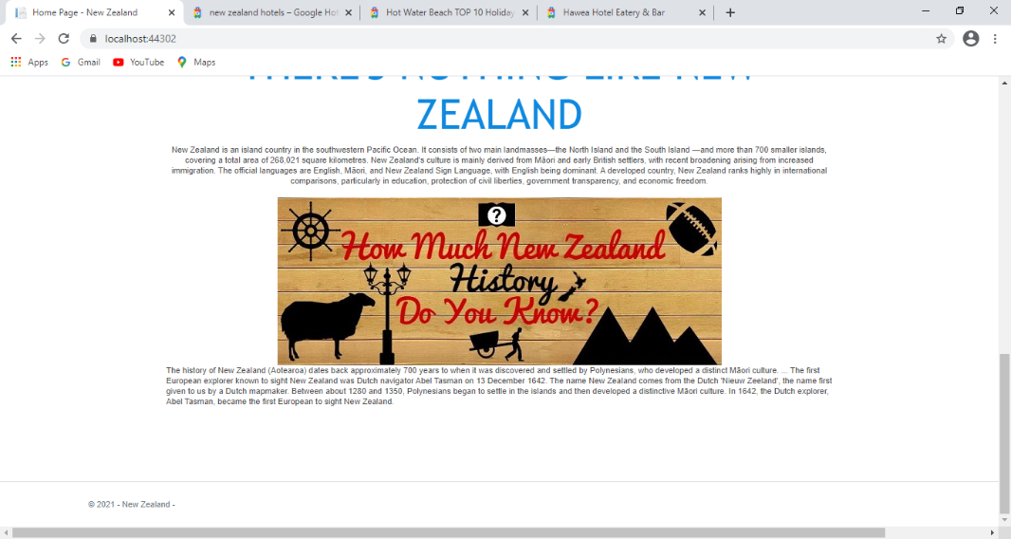

## Appearance / Style

### Colour schema

|  |  |  |  |
| --- | --- | --- | --- |
| Colour | Colour name | Colour code |  |
|  | Sky blue | **#2980B9** |  |
|  | Pink |  |  |
|  | white | **#FFFFFF** |  |

### Fonts

|  |  |  |
| --- | --- | --- |
| Font style | Font family | Used for |
| Calibri light (Headings) | Sans serif | Headings |
| Calibri (Body) | Sans serif | Information |
|  |  |  |

### Logo or Brand Name



Based on the name of New Zealand.

# Tasks Detail

Here you need to provide the Gantt chart with all tasks, estimate time for each task and total time estimation.

|  |  |  |
| --- | --- | --- |
| Weeks | Tasks | Time |
| 1 | Client details  Purpose  Goals  Features  Target audience | 60 minutes  20 minutes  20 minutes  20 minutes  20 minutes |
| 2 | Appearance and style  Page contact details  Wireframes  Sitemap  Domain names  Web hosting details | 50 minutes  140 minutes  60 minutes  20 minutes  40 minutes  20 minutes |
| 3 | Testing  Grammar, spellings ,links | 150 minutes |
|  | Total timing | 12 hr |

# Browser Support

The website used for NEW ZEALAND is a user friendly website which can be search on any browser like safari, Opera, Google chrome, Firefox, internet explorer and so on.

|  |  |  |
| --- | --- | --- |
| Number | Browser Name | Brower Version that support website |
| 1 | Safari | 5.1.7[11] (may9,2012) |
| 2 | Opera | 64 (2019) |
| 3 | Google chrome | 77.03865.120 |
| 4 | Firefox | 68.0.1 |
| 5 | Internet explorer | 11.0.155(8oct2019,6 days ago)[23] |

# Domain Names

The website used for NEW ZEALAND has some domain names which customer can use to open the website.

|  |  |
| --- | --- |
| No. | Domain names |
| 1 | www.new zealand.co.nz |
| 2 | www.nz group.co.nz |
| 3 | <https://nz,co.nz> |

# Web Hosting Companies Detail

The website used for the NEW ZEALAND has different hosting web companies like Host Papa, Blue host, register.com.

|  |  |  |
| --- | --- | --- |
| Number | Web Hosting Company Name | Price |
| 1 | Host Papa | Starting at $ 3.95 per month |
| 2 | Blue host | Starting at $ 4.18 per month |
| 3 | Register.com | Starting at $ 5.95 per month |

**REPORT ENDS!**